**1. Introduction** The Spotify Clone project aims to replicate the basic functionality and design of the popular music streaming platform, Spotify, using HTML, CSS, and JavaScript. The project focuses on building a user-friendly interface that allows users to search and play songs, create playlists, and customize their music listening experience. This report provides an overview of the project, its features, and the technologies used.

**2. Project Features** The Spotify Clone project incorporates the following features:

2.1 Playlists:

* Ability to play songs from playlists.
* Audio Progress bar.

**3. Technologies Used** The project utilizes the following technologies:

3.1 HTML:

* Structuring the web pages and creating the user interface elements.
* Implementing forms for user input and authentication.

3.2 CSS:

* Styling the HTML elements, including layout, color schemes, and typography.
* Responsive design for optimal viewing on different devices.

3.3 JavaScript:

* Handling user interactions and events.
* Manipulating the DOM to dynamically update the interface.

**4. Project Structure** The project follows a modular structure, dividing the functionality into separate components:

4.1 HTML Files:

* index.html: The main page containing the login and registration forms.

4.2 CSS Files:

* style.css: Contains the global styling rules for the application.

4.3 JavaScript Files:

* main.js: Handles the main functionality of the application, including authentication and DOM manipulation.

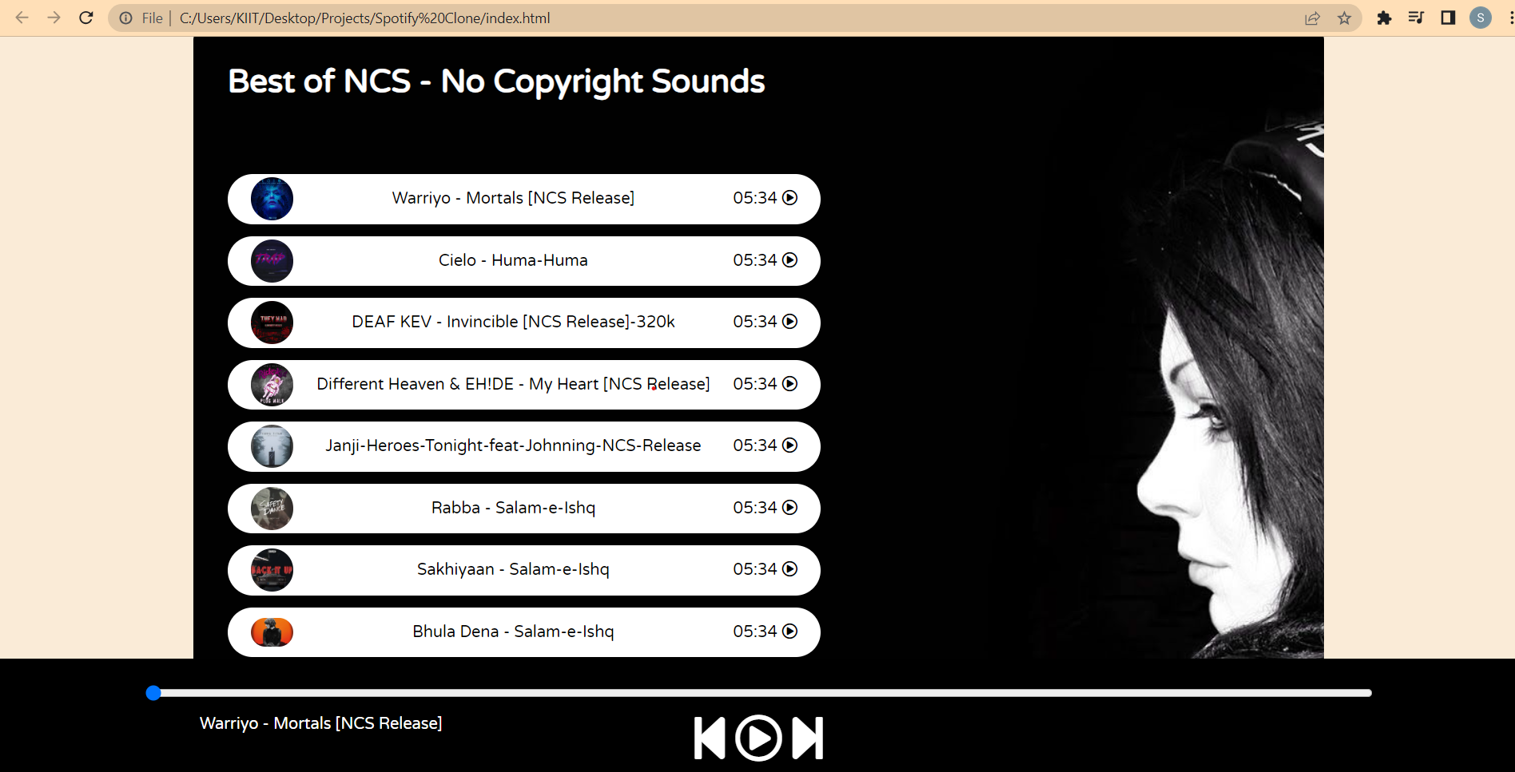

**Fig:1**

**5. Code**

**HTML-**<!DOCTYPE html>

<html lang="en">

    <head>

        <meta charset="UTF-8">

        <meta http-equiv="X-UA-Compatible" content="IE=edge">

        <meta name="viewport" content="width=device-width, initial-scale=1.0">

        <title>Spotify - Your favourite music is here</title>

        <link rel="stylesheet" href="style.css">

        </head>

<body>

    <nav>

        <ul>

            <li class="brand"><img src="logo.png" alt="Spotify"> Spotify</li>

            <li>Home</li>

            <li>About</li>

        </ul>

    </nav>

    <div class="container">

        <div class="songList">

            <h1>Best of NCS - No Copyright Sounds</h1>

            <div class="songItemContainer">

                <div class="songItem">

                    <img alt="1">

                    <span class="songName">Let me Love You</span>

                    <span class="songlistplay"><span class="timestamp">05:34 <i id="0" class="far songItemPlay fa-play-circle"></i> </span></span>

                </div>

                <div class="songItem">

                    <img alt="1">

                    <span class="songName">Let me Love You</span>

                    <span class="songlistplay"><span class="timestamp">05:34 <i id="1" class="far songItemPlay fa-play-circle"></i> </span></span>

                </div>

                <div class="songItem">

                    <img alt="1">

                    <span class="songName">Let me Love You</span>

                    <span class="songlistplay"><span class="timestamp">05:34 <i id="2" class="far songItemPlay fa-play-circle"></i> </span></span>

                </div>

                <div class="songItem">

                    <img alt="1">

                    <span class="songName">Let me Love You</span>

                    <span class="songlistplay"><span class="timestamp">05:34 <i id="3" class="far songItemPlay fa-play-circle"></i> </span></span>

                </div>

                <div class="songItem">

                    <img alt="1">

                    <span class="songName">Let me Love You</span>

                    <span class="songlistplay"><span class="timestamp">05:34 <i id="4" class="far songItemPlay fa-play-circle"></i> </span></span>

                </div>

                <div class="songItem">

                    <img alt="1">

                    <span class="songName">Let me Love You</span>

                    <span class="songlistplay"><span class="timestamp">05:34 <i id="5" class="far songItemPlay fa-play-circle"></i> </span></span>

                </div>

                <div class="songItem">

                    <img alt="1">

                    <span class="songName">Let me Love You</span>

                    <span class="songlistplay"><span class="timestamp">05:34 <i id="6" class="far songItemPlay fa-play-circle"></i> </span></span>

                </div>

                <div class="songItem">

                    <img alt="1">

                    <span class="songName">Let me Love You</span>

                    <span class="songlistplay"><span class="timestamp">05:34 <i id="7" class="far songItemPlay fa-play-circle"></i> </span></span>

                </div>

                <div class="songItem">

                    <img alt="1">

                    <span class="songName">Let me Love You</span>

                    <span class="songlistplay"><span class="timestamp">05:34 <i id="8" class="far songItemPlay fa-play-circle"></i> </span></span>

                </div>

                <div class="songItem">

                    <img alt="1">

                    <span class="songName">Let me Love You</span>

                    <span class="songlistplay"><span class="timestamp">05:34 <i id="9" class="far songItemPlay fa-play-circle"></i> </span></span>

                </div>

            </div>

        </div>

        <div class="songBanner"></div>

    </div>

    <div class="bottom">

        <input type="range" name="range" id="myProgressBar" min="0" value="0" max="100">

        <div class="icons">

            <!-- fontawesome icons -->

            <i class="fas fa-3x fa-step-backward" id="previous"></i>

            <i class="far fa-3x fa-play-circle" id="masterPlay"></i>

            <i class="fas fa-3x fa-step-forward" id="next"></i>

        </div>

        <div class="songInfo">

            <img src="playing.gif" width="42px" alt="" id="gif"> <span id="masterSongName">Warriyo - Mortals [NCS Release]</span>

        </div>

    </div>

    <script src="script.js"></script>

    <script src="https://kit.fontawesome.com/26504e4a1f.js" crossorigin="anonymous"></script>

</body>

</html>

**CSS-**

@import url('https://fonts.googleapis.com/css2?family=Ubuntu&display=swap');

@import url('https://fonts.googleapis.com/css2?family=Varela+Round&display=swap');

body{

    background-color: antiquewhite;

}

*{

    margin: 0;

    padding: 0;

}

nav{

    font-family: 'Ubuntu', sans-serif;

}

nav ul{

    display: flex;

    align-items: center;

    list-style-type: none;

    height: 65px;

    background-color: black;

    color: white;

}

nav ul li{

    padding: 0 12px;

}

.brand img{

    width: 44px;

    padding: 0 8px;

}

.brand {

    display: flex;

    align-items: center;

    font-weight: bolder;

    font-size: 1.3rem;

}

.container{

    min-height: 72vh;

    background-color: black;

    color: white;

   font-family: 'Varela Round', sans-serif;

   display: flex;

   margin: 23px auto;

   width: 70%;

   border-radius: 12px;

   padding: 34px;

   background-image: url('bg.jpg');

}

.bottom{

    position: sticky;

    bottom: 0;

    height: 130px;

    background-color: black;

    color: white;

    display: flex;

    justify-content: center;

    align-items: center;

    flex-direction: column;

}

.icons{

    margin-top: 14px;

}

.icons i{

    cursor: pointer;

}

#myProgressBar{

    width: 80vw;

    cursor: pointer;

}

.songItemContainer{

    margin-top: 74px;

}

.songItem{

    height: 50px;

    display: flex;

    background-color: white;

    color: black;

    margin: 12px 0;

    justify-content: space-between;

    align-items: center;

    border-radius: 34px;

}

.songItem img{

    width: 43px;

    margin: 0 23px;

    border-radius: 34px;

}

.timestamp{

    margin: 0 23px;

}

.timestamp i{

    cursor: pointer;

}

.songInfo{

    position: absolute;

    left: 10vw;

    font-family: 'Varela Round', sans-serif;

}

.songInfo img{

    opacity: 0;

    transition: opacity 0.4s ease-in;

}

@media only screen and (max-width: 1100px) {

    body {

      background-color: red;

    }

  }

**Javascript-**

console.log("Welcome to Spotify");

// Initialize the Variables

let songIndex = 0;

let audioElement = new Audio('songs/1.mp3');

let masterPlay = document.getElementById('masterPlay');

let myProgressBar = document.getElementById('myProgressBar');

let gif = document.getElementById('gif');

let masterSongName = document.getElementById('masterSongName');

let songItems = Array.from(document.getElementsByClassName('songItem'));

let songs = [

    {songName: "Warriyo - Mortals [NCS Release]", filePath: "songs/1.mp3", coverPath: "covers/1.jpg"},

    {songName: "Cielo - Huma-Huma", filePath: "songs/2.mp3", coverPath: "covers/2.jpg"},

    {songName: "DEAF KEV - Invincible [NCS Release]-320k", filePath: "songs/3.mp3", coverPath: "covers/3.jpg"},

    {songName: "Different Heaven & EH!DE - My Heart [NCS Release]", filePath: "songs/4.mp3", coverPath: "covers/4.jpg"},

    {songName: "Janji-Heroes-Tonight-feat-Johnning-NCS-Release", filePath: "songs/5.mp3", coverPath: "covers/5.jpg"},

    {songName: "Rabba - Salam-e-Ishq", filePath: "songs/2.mp3", coverPath: "covers/6.jpg"},

    {songName: "Sakhiyaan - Salam-e-Ishq", filePath: "songs/2.mp3", coverPath: "covers/7.jpg"},

    {songName: "Bhula Dena - Salam-e-Ishq", filePath: "songs/2.mp3", coverPath: "covers/8.jpg"},

    {songName: "Tumhari Kasam - Salam-e-Ishq", filePath: "songs/2.mp3", coverPath: "covers/9.jpg"},

    {songName: "Na Jaana - Salam-e-Ishq", filePath: "songs/4.mp3", coverPath: "covers/10.jpg"},

]

songItems.forEach((element, i)=>{

    element.getElementsByTagName("img")[0].src = songs[i].coverPath;

    element.getElementsByClassName("songName")[0].innerText = songs[i].songName;

})

// Handle play/pause click

masterPlay.addEventListener('click', ()=>{

    if(audioElement.paused || audioElement.currentTime<=0){

        audioElement.play();

        masterPlay.classList.remove('fa-play-circle');

        masterPlay.classList.add('fa-pause-circle');

        gif.style.opacity = 1;

    }

    else{

        audioElement.pause();

        masterPlay.classList.remove('fa-pause-circle');

        masterPlay.classList.add('fa-play-circle');

        gif.style.opacity = 0;

    }

})

// Listen to Events

audioElement.addEventListener('timeupdate', ()=>{

    // Update Seekbar

    progress = parseInt((audioElement.currentTime/audioElement.duration)* 100);

    myProgressBar.value = progress;

})

myProgressBar.addEventListener('change', ()=>{

    audioElement.currentTime = myProgressBar.value * audioElement.duration/100;

})

const makeAllPlays = ()=>{

    Array.from(document.getElementsByClassName('songItemPlay')).forEach((element)=>{

        element.classList.remove('fa-pause-circle');

        element.classList.add('fa-play-circle');

    })

}

Array.from(document.getElementsByClassName('songItemPlay')).forEach((element)=>{

    element.addEventListener('click', (e)=>{

        makeAllPlays();

        songIndex = parseInt(e.target.id);

        e.target.classList.remove('fa-play-circle');

        e.target.classList.add('fa-pause-circle');

        audioElement.src = `songs/${songIndex+1}.mp3`;

        masterSongName.innerText = songs[songIndex].songName;

        audioElement.currentTime = 0;

        audioElement.play();

        gif.style.opacity = 1;

        masterPlay.classList.remove('fa-play-circle');

        masterPlay.classList.add('fa-pause-circle');

    })

})

document.getElementById('next').addEventListener('click', ()=>{

    if(songIndex>=9){

        songIndex = 0

    }

    else{

        songIndex += 1;

    }

    audioElement.src = `songs/${songIndex+1}.mp3`;

    masterSongName.innerText = songs[songIndex].songName;

    audioElement.currentTime = 0;

    audioElement.play();

    masterPlay.classList.remove('fa-play-circle');

    masterPlay.classList.add('fa-pause-circle');

})

document.getElementById('previous').addEventListener('click', ()=>{

    if(songIndex<=0){

        songIndex = 0

    }

    else{

        songIndex -= 1;

    }

    audioElement.src = `songs/${songIndex+1}.mp3`;

    masterSongName.innerText = songs[songIndex].songName;

    audioElement.currentTime = 0;

    audioElement.play();

    masterPlay.classList.remove('fa-play-circle');

    masterPlay.classList.add('fa-pause-circle');

})

**6. Conclusion** -The Spotify Clone project successfully demonstrates the implementation of a music streaming application using HTML, CSS, and JavaScript. By replicating the core features of Spotify, users can search and play songs from create playlists Further enhancements could include additional features such as recommended songs, social sharing, and more advanced playlist management options.

Overall, the Spotify Clone project serves as a practical and educational exercise in web development and showcases the potential of HTML, CSS, and JavaScript for building interactive and engaging applications.